Concordia University

Department of Computer Science and Software Engineering

COMP 6231: Distributed Systems Design

STOCK BROKER SYSTEM: PROJECT MILESTONE #3

Team 3

Gay Hazan
Ross Smith
Patrick Cristofaro

July 26, 2015

Table of Contents
Overview 3
Architecture 3
Design 4
Business component 4
Exchange component 5
Broker component 6
Logger component 7
Improvements 7
Unused and deprecated methods 7
Synchronized methods in the logger 7
Include a release file for easier launching 8
Add some reliability to the logger 8
Improve concurrency by use of fine-grained synchronization 8
Testing 9
TestSuite.java 9
MultiThreadTest.java 9
FrontEnd package 10
Management 10
Release Notes 10
References 11

Overview
This project implements a stock exchange service, including a broker, a number of businesses, and an arbitrary number of clients.
“Stockbrokers receive requests from clients, buy/sell stocks on various stock exchanges. The application will have to query a real external stock quotes service, e.g., such as that of Yahoo, and simulate trades locally.” [Mokhov]
The third project milestone re-factors the previous CORBA implementation into a web services architecture. Our team has implemented both SOAP and RESTful web services, as shown below in Illustration 1.

Architecture
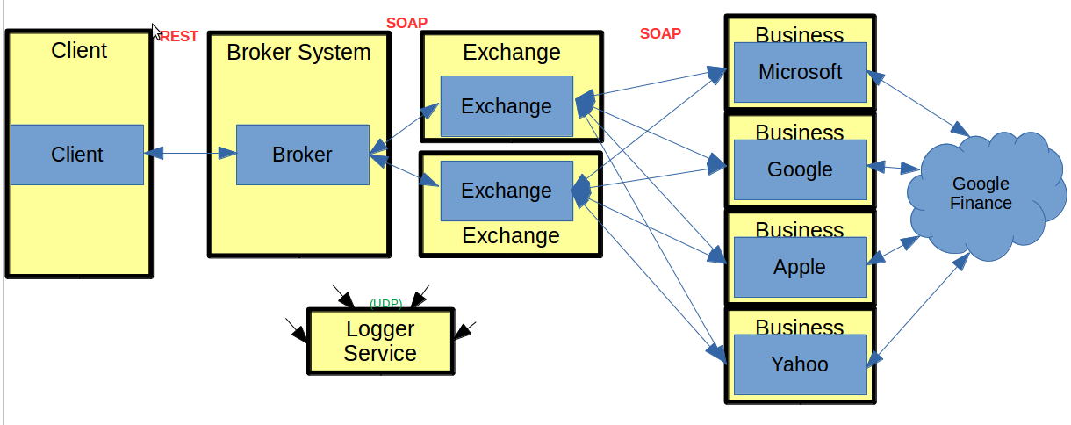Illustration 1: Architecture of the Stock Exchange, adapted from [Mokhov]
The system is based on four different server types, all running concurrently.
Client Server initiates orders and purchase shares by connecting to the broker. The system must support an arbitrary number of clients. For our purposes, JUnit tests simulate clients.
Stock Broker implements the broker class. For this project milestone, we have separated the broker and exchange servers.
Exchange Servers implement the exchange class. Two exchanges must run concurrently for this milestone.
Business servers represent individual companies with shares to sell. The system must support an arbitrary number of businesses, and retrieve stock prices from an internet web service.
Logger server collects information and error messages, saving them locally in a log file.
All communications between servers must use a Web Service implementation, with the exception of the logger, which shall use UDP.

Design
In this section, we will take a more detailed look at each architectural component, including the rationale behind our design decisions. We will also address some of the overall improvements made since the previous iteration.
The main focus of the discussion will be on new implementation relevant to this milestone.

Business component
The business component is implemented using JAX-WS and SOAP. Only the methods used by the Exchange are implemented within the interface.
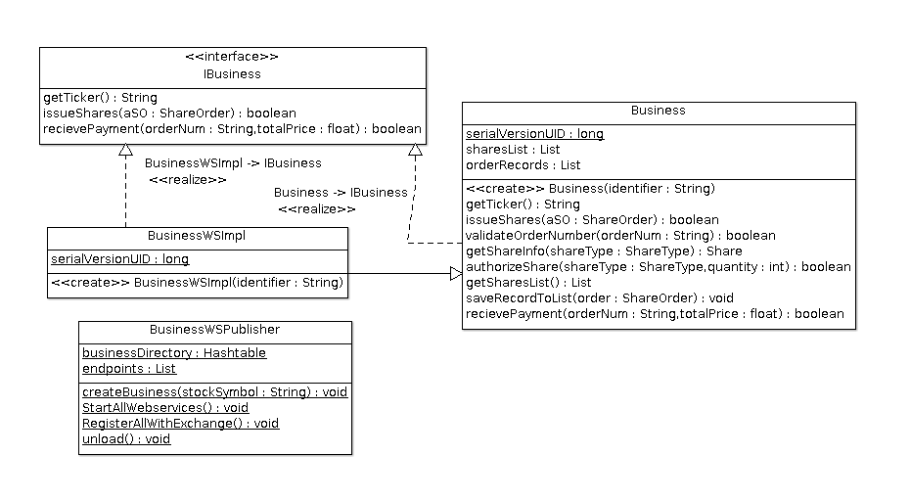Illustration 2: Classes and methods of the business component
The BusinessWSImplService class, which is auto-generated by JAX-WS, has been modified to support multiple web servers. The constructor requires one parameter, the stock symbol, and automatically determines the correct endpoint and WSDL for that business. In this way, a single implementation can support unlimited instances of the Business class.
BusinessWSPublisher is a convenience class that allows businesses to be launched easily and without replicating code. Calling createBusiness() adds a business to a list of potential servers. Once the list is fully populated, calling StartAllWebservers() will instantiate endpoints for each business. Finally, calling RegisterAllWithExchange() will register all businesses on the exchange(s).

Exchange component
The exchange is one of the more complex components of the software system. It must keep a record of all businesses that can sell shares, it must keep a local cache of shares that are available for sale, and it must respond to purchase orders from the broker.
Illustration 3: Main classes of the Exchange
The exchange work flow is as follows:

- The exchange server starts up.
- A business registers with the exchange. The exchange asks the business to issue some shares. These shares have not been purchased yet; the exchange will hold them locally in a cache. The business keeps a record of this “debt” for later payment.
- The broker asks to buy some shares.
  - The exchange sells its cached shares first. This allows for the fastest transaction time.
  - If the exchange doesn't have enough shares, it will ask the business for more.
- Once the transaction is complete, the exchange will replenish the local cache, as required.
- When enough shares have been sold to pay back the business, the exchange will issue a payment to the business, who will record that the debt is now paid.

Broker component
The design of the broker parallels that of the business component. The original Broker from milestone #1 is virtually unchanged, and a Servant is added to provide an interface to the Broker methods.
Just as in BusinessServer, the Broker has a BrokerServer class that acts as a helper to get the BrokerServer up and running.
Illustration 4: The classes of the Broker component

Logger component
Illustration 5: Classes that comprise the Logger
The logger component is virtually unchanged from the previous iteration, except for a small performance improvement regarding synchronization. It uses UDP to accept messages from all other system components, and saves them to file.
The logger can easily be run on any server with a known IP address. The user simply needs to update the Config.json file with the correct information.

Improvements
Our second iteration improved significantly on some weaker aspects of our design. For the third iteration, we continued to address issues of quality and performance, as outlined in this section.

LoggerThread should not lock LoggerThread.class
This issue has been resolved by creating a lock object only for the file write operation.

GenerateOrderNumber in Exchange uses method synchronization
The lock has been changed to a class-level lock.

Get rid of 33 warnings
The warnings that were present in the previous milestone have all been removed.

Show start and end time for MultiThread test
text

Testing
This section will outline the tests we have included in the project submission. All tests use JUnit4. For all tests, the user must ensure that the Naming Service is running on the correct port, as outlined in the README.md file.

TestSuite.java
The TestSuite JUnit conveniently sets up all the servers and runs all other JUnit tests. Simply launch it from Eclipse and observe the output on the console, or in the files/iteration_2.log file.
The TestSuite includes all integration and unit tests, but not the stress test.
Illustration 6: Running the test suite | Illustration 7: Test suite in progress

MultiThreadTest.java
Concurrency is a critical feature of distributed systems. To test concurrency in our software package, we include the MultiThreadTest JUnit. The test launches four businesses, fifteen clients and tries to issue 90,000 purchase orders per client for a total of 1.35 million transactions.
The orders are random, and some are intentionally invalid. The system must respond to the stress resiliently and recover from invalid orders cleanly.
To run the test, simply launch it the same way as TestSuite.java.

FrontEnd package
Also included is a FrontEnd that makes it possible to run the software package as a real-life simulation.
Simply run FrontEnd.java and use the console to interact with the system. Valid stock symbols are GOOG, MSFT, AAPL and YHOO.
Illustration 8: Using the FrontEnd client interface

Management
For this milestone, we continued to use JIRA Agile as our primary tool for coordinating tasks between team members. The server is located at http://jira.homelinux.org. Access can be provided on request.
Illustration 9: JIRA Agile continues to be the project's task-management system

Release Notes
Please see the README.md in the project root folder for important details about this release, including basic instructions on running and links to the detailed Javadoc.

References

[Mokhov] | Mokhov, Serguei A. COMP6231: Distributed Systems Design TENTATIVE PROJECT DESCRIPTION (Revisions 2.2), June 2015.
[Oracle] | http://docs.oracle.com/javase/7/docs/api/java/util/ArrayList.html, June 27, 2015.
[IBM] | http://www.ibm.com/developerworks/library/ws-restful/
[Nordic] | http://nordicapis.com/rest-vs-soap-nordic-apis-infographic-comparison/
[Oracle2] | http://www.oracle.com/technetwork/articles/java/restful-142517.html

Appendix A: Response to Questions

How are webservices implemented in JSP? When should REST be used, and when is SOAP better? What are the pros and cons of each?

RESTful services use HTTP explicitly, are stateless, expose directory structure-like URIs and transfer XML and/or JSON formats [IBM]
GET reads, POST creates, PUT updates and DELETE deletes
Reduces reliance on middleware which in turn simplifies load balancing. Links are bookmarkable.
SOAP uses WSDL to define what services are available. RESTful services use intuitive directory-style structures.

Use RESTful web services for applications operating on a web environment that does not require access to the data objects themselves. RESTful is also advantageous when bandwidth is limited, such as for mobile applications. [Nordic]
SOAP is preferable when direct access to server objects is needed, or when greater security is necessary. [Nordic] Whenever specific contracts are needed between server and client, or capability beyond simple CRUD operations, SOAP is the better choice [Oracle2]. This flexibility comes at a cost, however, and SOAP operations have a high overhead bandwidth cost.
REST embraces the open standards of the internet, and if done correctly, has implementations that are relatively intuitive to understand. [IBM] For example, a RESTful GET request to http://www.payments.com/invoicelist/2015/05/18 can be expected, with little thought, to return the list of invoices for May 18, 2015. However, RESTful services may not be the right choice if your server objects are not stateless. A good test would be to consider if your objects would survive a server restart [Oracle2]. If not, they might not be right for REST.

Appendix B: Change Log

Please refer to GITHUB for the changelog history.

